Name: __________________________________________Date: ____________

- For the following identify the solute and solvent
SITUATION | SOLUTE | SOLVENT
- 5 moles of acetic acid are mixed with 30 moles of
water to make vinegar
B) A lake is polluted with nitrogen and phosphorus
c) 0.75 grams of perfume is sprayed and diffuses throughout
the air we breathe.

D) Sugar is dissolved in tea to make it sweet!

E) Oxygen and carbon dioxide molecules travel throughout
blood.

- Name three factors that influence the rate at which a solute dissolves in a solvent
- Use the following words in a sentence:
- Solubility
- Saturated
- Unsaturated
- Miscible
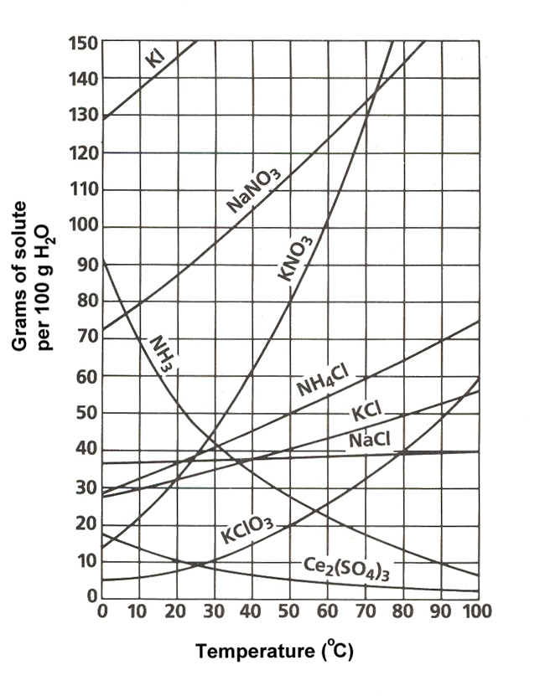
- Immiscible
- Supersaturated

Part One: Reading Solubility Curves
Use the graph to answer the following questions. REMEMBER UNITS!

- What mass of solute will dissolve in 100 g of water at the following temperatures?
  - KNO₃ at 70°C ____________
  - NaCl at 100°C ____________
  - NH₄Cl at 90°C ____________
  - Which of the above three substances is most soluble in water at 15°C. ____________

Part Two: Types of Solutions (saturated, unsaturated, supersaturated)
On a solubility curve, the lines indicate the concentration of a __________________ solution - the maximum amount of solute that will dissolve at that specific temperature.
Values on the graph ____________ (below, above, on) a curve represent unsaturated solutions - more solute could be dissolved at that temperature.
Use the solubility curve on the first page to label the following solutions as saturated or unsaturated. If unsaturated, write how much more solute can be dissolved in the solution.
Solution | Saturated or Unsaturated? | If unsaturated: How much more solute can dissolve in the solution?
a solution that contains 70g of NaNO₃ at 30°C (in 100 g H₂O)
a solution that contains 50g of NH₄Cl at 50°C (in 100 g H₂O)
a solution that contains 20g of KClO₃ at 50°C (in 100 g H₂O)
a solution that contains 70g of KI at 0°C (in 100 g H₂O)

Additional Practice:
1. a. At 90°C, you dissolved 10 g of KCl in 100. g of water. Is this solution saturated or unsaturated?
b. How do you know?
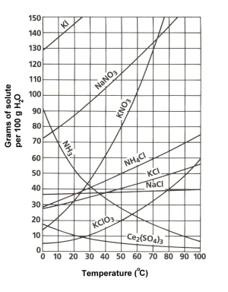
2. A mass of 100 g of NaNO₃ is dissolved in 100 g of water at 80ºC.
a) Is the solution saturated or unsaturated?______________________________
b) As the solution is cooled, at what temperature should solid first appear in the solution? Explain.
3. Use the graph to answer the following two questions:
Which compound is most soluble at 20 ºC? ________
Which is the least soluble at 40 ºC? ________

4. Which substance on the graph is least soluble at 10°C? _______

5. A mass of 80 g of KNO₃ is dissolved in 100 g of water at 50 ºC. The solution is heated to 70ºC. How many more grams of potassium nitrate must be added to make the solution saturated? Explain your reasoning

