Name: _____________________ Period: _____ Date: ____________________
Reaction Unit Overview

Section 1: Identify the type of reaction
For the following reactions, indicate whether the following are examples of synthesis, decomposition, combustion, single replacement, or double replacement:

1) Na₃PO₄ + 3 KOH 3 NaOH + K₃PO₄ _________________________
2) MgCl₂ + Li₂CO₃ MgCO₃ + 2 LiCl _________________________
3) C₆H₁₂ + 9 O₂ 6 CO₂ + 6 H₂O _________________________
4) Pb + FeSO₄ PbSO₄ + Fe _________________________
5) CaCO₃ CaO + CO₂ _________________________
6) P₄ + 3 O₂ 2 P₂O₃ _________________________
7) 2 RbNO₃ + BeF₂ Be(NO₃)₂ + 2 RbF ________________________
8) 2 AgNO₃ + Cu Cu(NO₃)₂ + 2 Ag ________________________
9) C₃H₆O + 4 O₂ 3 CO₂ + 3 H₂O _________________________
10) 2 C₅H₅ + Fe Fe(C₅H₅)₂ _________________________
11) 2 MgI₂ + Mn(SO₃)₂ 2 MgSO₃ + MnI₄ _________________________
12) 2 NO₂ 2 O₂ + N₂ _________________________

Section 2: Practicing equation balancing
For the following equations, write in the coefficients necessary to follow the Law of the Conservation of Matter.

1) __ C₆H₆ + __ O₂ __ H₂O + __ CO₂
2) __ NaI + __ Pb(SO₄)₂ __ PbI₄ + __ Na₂SO₄
3) __ NH₃ + __ O₂ __ NO + __ H₂O
4) __ Fe(OH)₃ __ Fe₂O₃ + __ H₂O
5) __ HNO₃ + __ Mg(OH)₂ __H₂O + __ Mg(NO₃)₂
6) __ H₃PO₄ + __ NaBr __ HBr + __ Na₃PO₄
7) __ C + __ H₂ __ C₃H₈
8) __ CaO + __ MnI₄ __ MnO₂ + __ CaI₂
9) __ Fe₂O₃ + __ H₂O __ Fe(OH)₃
10) __ C₂H₂ + __ H₂ __ C₂H₆
11) __ VF₅ + __ HI __ V₂I₁₀ + __ HF
12) __ OsO₄ + __ PtCl₄ __ PtO₂ + __ OsCl₈
13) __ CF₄ + __ Br₂ __ CBr₄ + __ F₂
14) __ Hg₂I₂ + __ O₂ __ Hg₂O + __ I₂
15) __ Y(NO₃)₂ + __ GaPO₄ __ YPO₄ + __ Ga(NO₃)₂

Section 3: Word Problems
Write out the reaction from the formula names. Make sure you remember to balance formulas and the entire equation.

1) Zinc and lead (II) nitrate react to form zinc nitrate and lead.
2) Aluminum bromide and chlorine gas react to form aluminum chloride and bromine gas.
3) Sodium phosphate and calcium chloride react to form calcium phosphate and sodium chloride.
4) Potassium metal and chlorine gas combine to form potassium chloride.
5) Hydrogen gas and nitrogen monoxide react to form water and nitrogen gas.

Section 4: Predicting the products of chemical reactions
For the following equations, write the type of reaction as well as the products. Make sure your final equation is balanced correctly. If it’s a double replacement reaction, make sure you include the states of matter. For three of the questions, you are also asked to include the net ionic equation.

1) __ Ag + __CuSO₄ Type:___________________________
2) __ NaI + __ CaCl₂ Type:___________________________
3) __ O₂ + __ H₂ Type:___________________________
4) __ AgNO₂ + __ BaSO₄ Type:___________________________
Net Ionic:
5) __ HCN + __ CuSO₄ Type:___________________________
6) __ AgBr + __ Co(SO₄)₂ Type:___________________________
Net Ionic:
7) __ LiNO₃ + __Ag Type:___________________________
8) __ Sr + __ O₂ Type:___________________________
9) __ H₂CO₃ Type:___________________________
10) __ AlCl₃ + __ Zn Type:___________________________
11) __ Al(NO₃)₃ + __ Rb Type:___________________________
12) __ C₂H₄O₂ + __ O₂ Type:___________________________
13) __ C₄H₈ + __ O₂ Type:___________________________
14) __ KCl + __ Pb(OH)₂ Type:___________________________
Net Ionic:
15) __ Zn + __ Au(NO₃)₂ Type:___________________________
16) __ BaS + __ PtCl₂ Type:___________________________
17) __ Na₂O Type:___________________________

Section 5: Energy and Reaction Rate

1) Classify each of the following as endothermic or exothermic:

A. heat + AB A + B
B. Energy is absorbed
C. Temperature increases during a reaction
D. A + B AB + ∆H
E. energy is released
F. The reaction feels cold
G. 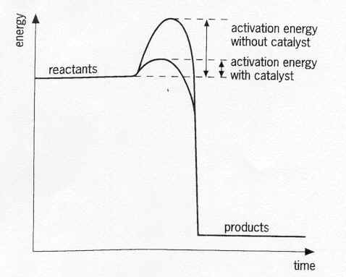

2) Which of the following will increase the reaction rate:

a. Place the reactants in an ice water bath b. Break a large piece of a reactant into many smaller pieces
c. Add a catalyst to the reaction d. Decrease the concentration of a reactant from 7 M to 5 M

