Name:________________________________
Plate Tectonics Study Guide
Ch & Sec Vocabulary

8.1 1. _____ focus (p. 218) a. layer of the Earth that is made of the lower mantle
2. _____ epicenter b. fracture in which the movement of the plates are horizontal & parallel to each other
3. _____ fault c. destructive, volcanic mudflow made of a mixture of water, dirt, & ash
4. _____ elastic rebound d. instrument used to detect earthquake waves
5. _____ aftershock e. when two oceanic plates form a mid-ocean ridge at a divergent boundary
8.2 6. _____ seismograph f. characteristic of ancient rocks that shows the location of magnetic poles
7. _____ momentum magnitude g. the springing back of a rock back to its original position
8.3 8. _____ liquefaction h. occurs when one oceanic plate is forced down beneath a second plate
9. _____ tsunami i. point within the Earth where an earthquake starts
8.4 10._____ lithosphere j. undersea mountains created in the middle of a plate over a hot area of the mantle
11._____ asthenosphere k. when loose soil becomes saturated with water & can’t support buildings

9.3 12._____ rift (p.258) l. smaller earthquake that follows a major earthquake
13._____ seafloor spreading m. a fracture in the Earth where plate movement has occurred
14._____ subduction zone n. important mechanism for causing plate motion when cool crust sinks
9.4 15._____ paleomagnetism o. widely used scale to measure earthquake intensity
16._____ hot spot p. circular movement of liquid cool mantles sinking & hot mantle rising
9.5 17._____ slab-pull q. layer of the Earth that is made the crust & upper mantle
18._____ convection r. seismic sea wave caused by an earthquake under the ocean
10.1 19._____ lahar (p. 286) s. location on the surface directly above the focus of an earthquake
11.1 20._____ strike-slip fault t. a tear or rip in something

21. Use notes & textbook Sec 9.2 to fill in the correct term from the word bank:
Plate Boundaries | Divergent | Convergent | Transform
movement | plates move _________ | plates move ___________ | plates grinds past each other
structures | - ______ _______  - _____ ________  - seafloor spreading | - _________ _____  - _______ _______  - mountain building
example | ___ ________ _______ | ________ ____________ | _____ __________ ________
lithosphere created or destroyed | lithosphere ________ | lithosphere ___________ | _________
word bank: San Andreas Fault rift valley subduction zone destroyed oceanic ridge
neither together Mid-Atlantic Ridge created volcanic activity apart Andes Mountains

22. Use textbook Sec 9.3 to fill in the correct term from the word bank:
Action at boundaries | ocean-ocean | ocean-continent | continent-continent
Convergent Boundary  (p. 261) | _______ _____ , ocean trench, volcanic _______ _____ | subduction zone, ______ _____, __________ on continent | ___________
Divergent Boundary  (p. 258) | ________ ________ |  | _____ _______
word bank: rift valley volcanoes subduction zone oceanic ridge
mountains ocean trench island arc

23. Plate Movement: | Slab-Pull mechanism (p. 269) | Ridge-Push mechanism (p. 269) | Mantle Convection (p. 269)
explain how it works:

example: |  |  | mantle plumes

24. On the following seismogram label the P, S & surface wave.
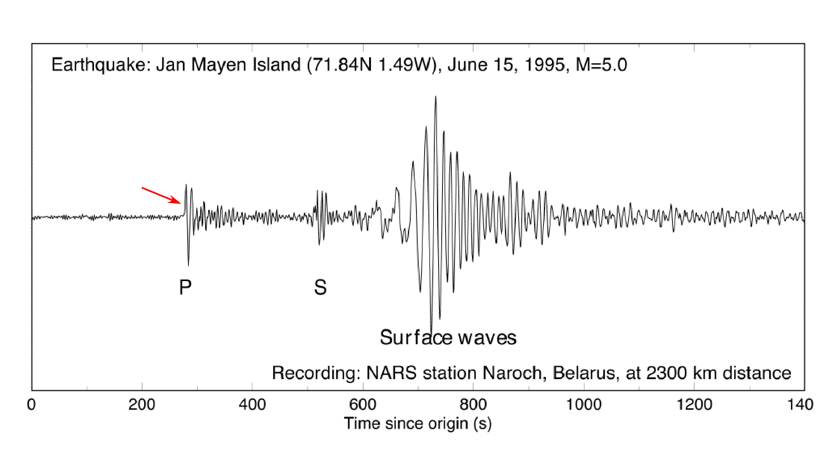
25. Describe each of the following steps for how you would locate an earthquake epicenter:
1. How & why energy is released within rock:

2. How a seismograph works & the information you get from P & S waves:

3. How to use a Time-Distance Earthquake Chart:

4. How to use a map to locate the epicenter:

26. What determines the amount of damage that can occur as a result of an earthquake?

27. Can the exact time and location of an earthquake be predicted? Circle: yes no

28. Describe how an early warning system for an earthquake or tsunami could be designed and used?

29. Use textbook Sec. 11.1 to fill in the correct term from the word bank:
Faults | Normal | Reverse | Strike-Slip
movement | plates moves ______ | plates moves _________ | plates grinds past each other
type of boundary | ______________ | ________________ | ________________
hanging wall moves? | ________ | ____
word bank: together down divergent up transform apart convergent

30. Make a simple drawing for the 3 types of faults in question #29 above.

