Name

PHASE DIAGRAM WORKSHEET
Part A – Generic Phase Diagram.
Answer the questions below in relation to the following generic phase diagram.

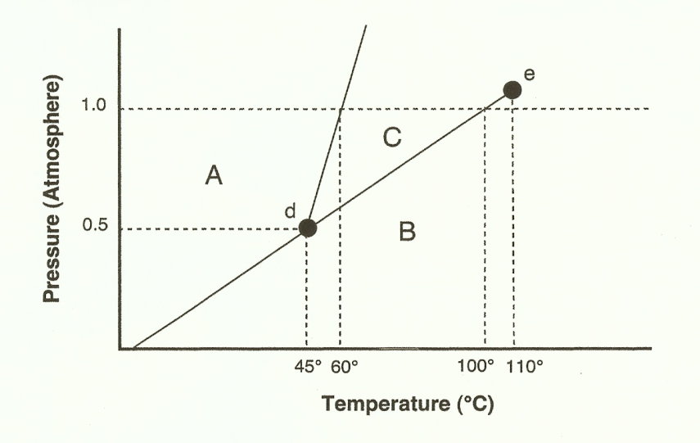
1. Which section represents the solid phase? ________
2. What section represents the liquid phase? ________
3. What section represents the gas phase? ________
4. What letter represents the triple point? ________
5. What is this substance’s normal melting point, at 1 atmosphere of pressure? _________
6. What is this substance’s normal boiling point, at 1 atmosphere of pressure? _________
7. Above what temperature is it impossible to liquefy this substance, no matter what the pressure? _____
8. At what temperature and pressure do all three phases coexist? ___________________
9. At a constant temperature, what would you do to cause this substance to change from the liquid phase to the solid phase?
10 What does sublimation mean?
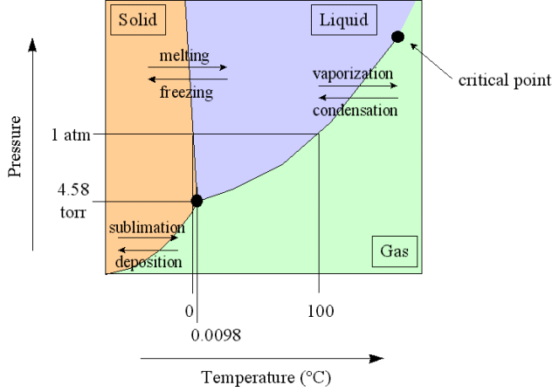
Part B – Phase Diagram for Water.
11. At a pressure of 1 atmosphere, what is the normal freezing point of water? ________
12. What is the normal boiling point of water, at one atmosphere of water? ________
13. In Albuquerque, people live approximately 5,500 feet above sea level, which means the normal atmospheric pressure is less than 1 atm. In Albuquerque, will water freeze at a lower temperature or a higher temperature than at 1 atmosphere? _________
Will water boil at a higher or lower temperature, than at 1 atmosphere?
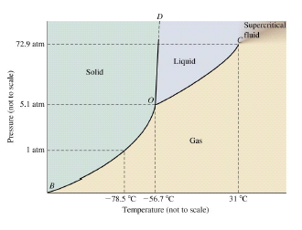
Part C – Phase Diagram for Carbon Dioxide.

14. At 1 atmosphere and room temperature (25°C), would you expect solid carbon dioxide to melt to the liquid phase, or sublime to the gas phase? ________
15. Some industrial processes require carbon dioxide. The carbon dioxide is stored on-site in large tanks as liquid carbon dioxide. Assuming we lived at sea level (1 atm), how could carbon dioxide be liquefied?

Part D: Complete the following phase change calculations.
1. How much energy is needed to melt 35 grams of ice?

2. How much energy is needed to vaporize 55 grams of liquid water?

3. An iceberg is found to have a mass of 1.984 x 10⁸ grams. How much energy will the sun need to produce in order to melt this ice berg?

4. How much energy is required for the sun to expand and evaporate all of the Earth’s oceans if the mass of the oceans is estimated to be 1.384 x 10²¹ kilograms?

Part E: Complete the following heating curve calculations.
1. You are camping in the winter and have 30g of ice at 0 °C that you need to melt and heat up so that you’ll have warm drinking water (40 °C).
a. Draw a phase change diagram to indicate the changes water will undergo in this problem & label each step
b. How much total heat (Joules) is needed to do the problem above?

2. How many joules are needed to convert 12.0g of liquid water at 15.0°C to water vapor at 125.0°C?

3. 10.0 g of steam at 120.0 °C are converted into ice at -20.0°C.
a. Draw the phase change diagram to indicate this change.
b. Calculate the total energy released (J) needed to do the problem above.

4. 15.6 g of ice at -12.0 °C are converted into water vapor at 200.0°C.Calculate the energy in joules needed to achieve this.

Part D: Complete the following phase change calculations.
1. How much energy is needed to melt 35 grams of ice?

2. How much energy is needed to vaporize 55 grams of liquid water?

3. An iceberg is found to have a mass of 1.984 x 10⁸ grams. How much energy will the sun need to produce in order to melt this ice berg?

4. How much energy is required for the sun to expand and evaporate all of the Earth’s oceans if the mass of the oceans is estimated to be 1.384 x 10²¹ kilograms?

Part E: Complete the following heating curve calculations.
1. It takes 2,000 Joules of heat to raise the temperature of 44.6 g of an unknown metal 50°C. What is the identity of the metal?

2. How many joules are needed to convert 12.0g of liquid water at 100.0°C to water vapor at 100.0°C?

3. If 225 Joules of heat are added to 37 grams of 12°C lead, what is the final temperature of the metal? Lead’s specific heat is 0.129 J/g°C.

4. How much heat energy is necessary to melt 15.6 g of ice?

