**Phase & Vapor Pressure Diagrams**

1. Use the phase diagram below for iodine to answer the following questions.



a. What is the temperature and pressure at which all three phases coexist? ____________________

b. What is the melting point at 73.0 atm?_____________________________

c. What phase(s) is/are present at -78.5°C and 1 atm?_____________________________

d. What phase(s) is/are present at -57°C and 39 atm?_____________________________

1. The phase diagram for sulfur is shown below. Rhombic and monoclinic are two allotropic solid phases.

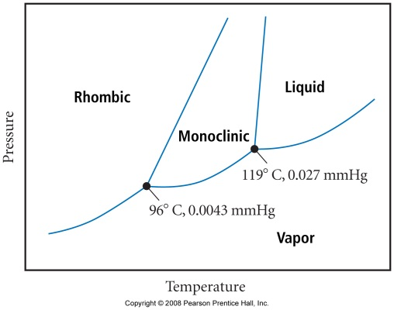

a. Below what pressure will solid sulfur sublime?_____________________________

b. Which of the two solid phases is more dense?_____________________________

Answer questions 3-8 using the following graph

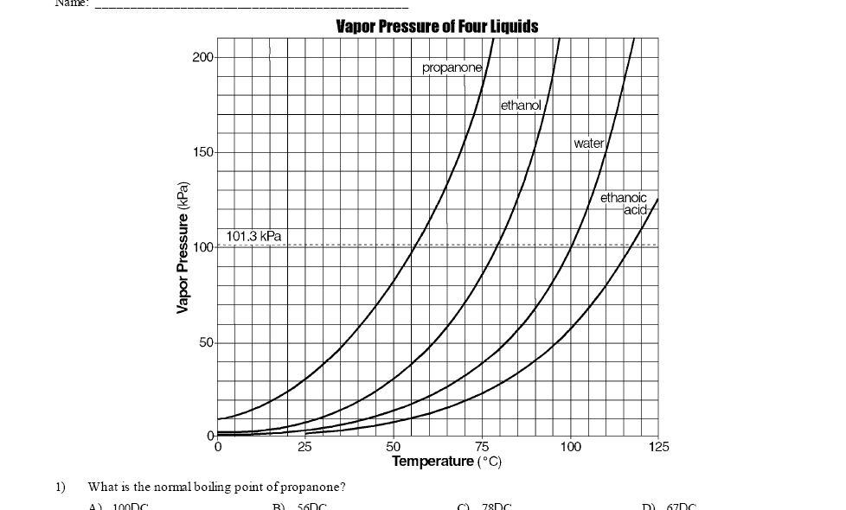

1. What is the boiling point of ethanol at 101.3 kPa? ____________________
2. Which liquid has the *highest* vapor pressure at 50°C? __________________
3. According to the table, which liquid has a normal (standard) boiling point of 79°C? _______
4. A unknown liquid has a vapor pressure of 150 kPa at 90°C. This liquid is *most* likely ______
5. In a laboratory experiment, students measured the vapor pressure of two unknown liquids. Their data is recorded in the table below. Based on the data shown, substance *Y* could be
6. 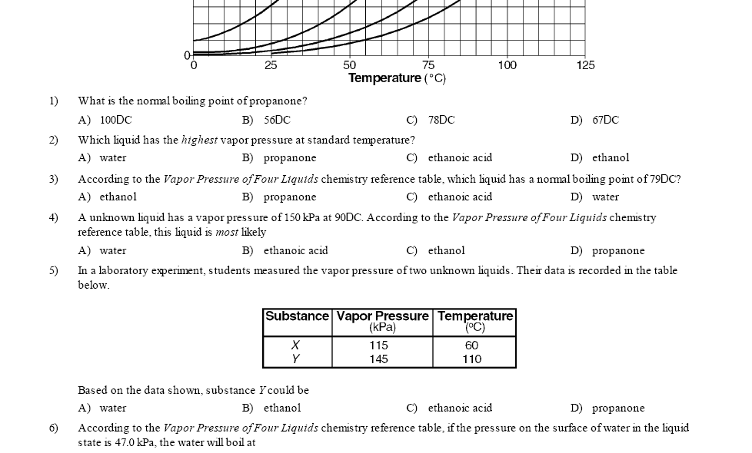 Atmospheric pressure on the top of Mount Everest is 0.33 atm. At what temperature would water boil? __________________
7. Using information from your notes, complete the following table.

*Name of Process*  *Endothermic or Exothermic?*

solid → liquid

liquid → solid

liquid → gas

gas → liquid

solid →gas

gas → solid

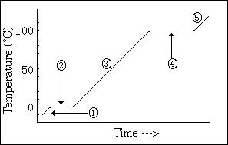

1. As a substance goes through section (4), what happens to the distance between the particles?

1. What is the name of the process happening during section (2)?

1. What would be the name of the process happening during section (4) if time were going the other way?

1. What is the melting point of this substance?

1. At what temperature would this sample finish boiling?

1. The temperature at which a substance in the liquid state freezes is the same as the temperature at which the substance ____.
   1. melts b. sublimes c. boils d. condenses
2. Where is the energy going in stage 2 if the temp is not rising?
3. Name the two phase changes that can occur at stage 2? At stage 4.