Mole Conversion Practice Problems
- How many atoms are in 0.250 mol of silver? _____________ atoms

- How many moles are in 3.25X10²⁰ atoms of Pb? __________moles

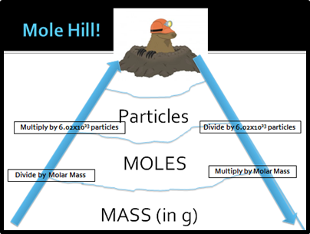
- Convert 1.51 x 10¹⁵ atoms Si to mol Si. __________________ mol

- How many molecules are in 1.35 mol CS₂? ____________molecules

- How many moles are in 1.25 X 10¹⁵ molecules of CO₂? _______ mol

- What is the mass of 5.22 mol He? ____________g

- Convert 3.50 mol Li to grams Li. ____________g
Divide by 6.02 x 10²³
Multiply by 6.02 x 10²³
- What’s the mass (grams) of 1.33 x 10 ²² mol of Sb? ___________g

- What’s the mass (grams) of 4.22 x 10 ¹⁵ atoms of U? ___________g

- How many atoms are in 25.8 g Hg? ____________atoms

- What’s the molar mass of nitric acid (HNO₃) ____________g/mol

- What’s the molar mass of ascorbic acid (C₆H₈O₆) __________g/mol

- How many moles are in 100.0g of dinitrogen oxide (N₂O)?
_______________mols
- How many atoms are in 3.50 g of gold? __________________g

