Climate & Energy Study Guide
Match the climate with the description
- Dry a. Has different seasons and a good amount of rain
- Humid Mid-Latitude b. Has no winters and a good amount of rain
- Polar c. Has a different climate because it is at a higher elevation
- Humid Tropical d. Extremely cold, found at high latitudes
- Highland e. Receives very little rainfall all year

- What are 3 major greenhouse gases?

- On the picture below, draw arrows from the words in boxes to the appropriate places on the diagram. When done, write a sentence about the greenhouse effect using the following words: Long wave radiation, short wave radiation, absorption, re-radiation, greenhouse gasses, Earth’s surface, the atmosphere.
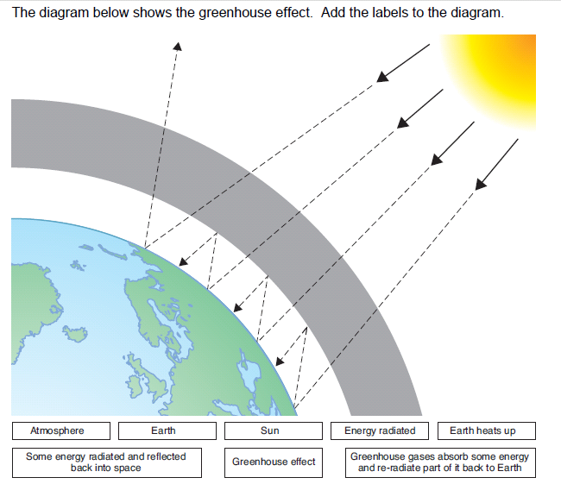

- How does deforestation affect the carbon cycle?

- What is the biggest contributor of CO2 created by man?

- How does each of the following affect climate?

  - Latitude

  - Elevation

  - Water Bodies

- How do each of the following change climate?
a. Solar activity

b. Volcanic activity

c. CO2 Fluctuations

d. Earth Motions

- What acid is created when CO2 is added to ocean water? How does this affect sea life?

- How will North Carolina and other coastal cities be affected by climate change?

- What is an urban heat island? How does it form?

- Explain the difference between a renewable & nonrenewable resource.

- What are fossil fuels (hydrocarbons) & how were they made?

- What single nonrenewable resource is used to make fuel, gasoline, petrol, kerosene, butane, diesel fuel, grease, styrofoam, nylon, jet fuel, synthetic rubber, pharmaceuticals, solvents, fertilizers, asphalt, pesticides, acrylics, PVC, polyester, lubricants, waxes, tar, & plastics? (hint: one word, starts with “P”)

- Briefly describe how the following renewable resources work & where they would work best in N.C.:
wind energy –

solar energy –

hydroelectric energy –

tidal energy –

nuclear energy –

